University of North Texas (UNT), CSCE 5430, Software Engineering
Deliverable 4: User Manual
Lost and Found for Campus, Phase 2: Team Falcons, CSCE 5430, Fall 2026
Every screen shown in this manual is a faithful, pixel accurate recreation built directly from the project's real page components and stylesheet, reproducing the exact labels, fields, buttons, and messages the application uses. They were generated this way because a live, running instance was not reachable from the environment this manual was prepared in; they are not AI generated impressions of a hypothetical design.

1. Introduction
Lost and Found for Campus is a web application that lets students, faculty, and staff report lost or found items, search existing listings, and manage the listings they have posted themselves. Phase 2 adds automated matching: when you post a listing, the system finds similar items already posted and notifies both you and the person who found (or lost) the match. You can then submit identifying details called evidence to claim a match, the owner reviews your claim, and if approved, a secure in-app messaging channel opens so you can coordinate the handoff.
This manual covers all Phase 2 features: everything from Phase 1 (creating an account, verifying your email, signing in, resetting a forgotten password, browsing and searching listings, creating a Lost or Found listing with photos, and editing or removing your own listings), plus the new Phase 2 workflows (receiving and understanding match notifications, submitting claim evidence, reviewing claims you have received, and using the in-app messaging system to coordinate handoffs).
This manual is written for the people who will use the application day to day. If you are looking for instructions on installing dependencies and running the project from source code, see the separate Compilation and Run Instructions document.

2. Accessing the Application
Open a supported web browser (current Chrome, Edge, Firefox, or Safari) on a desktop, laptop, tablet, or phone. No specialized hardware, plugin, or app installation is required.
During development and grading, the application runs locally. Your instructor or team will provide the address to open; by default this is http://localhost:5173 for the site itself. You do not need to know or type any backend or database address; the page you open talks to the server automatically.

3. Creating an Account
Select Register from the top navigation bar. You will need:
- Your first and last name.
- A campus email address ending in @unt.edu or @my.unt.edu. Any other email address is rejected with an on-screen message.
- A password of at least 8 characters.
After you submit the form, your account is created immediately, but it is not yet verified. The application automatically sends a verification email to the address you registered with.
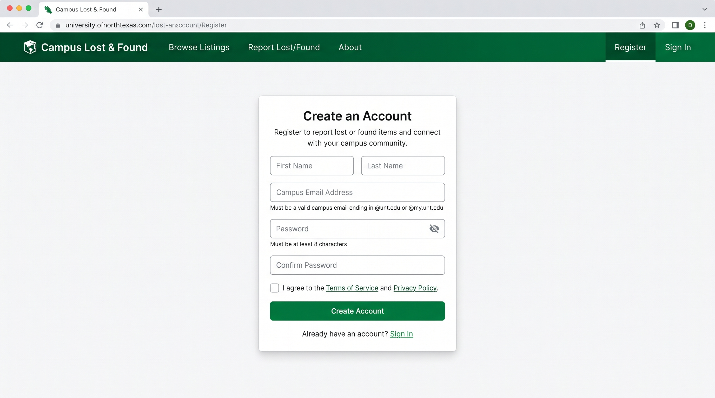
Figure 1. Register page

4. Verifying Your Email
Open the verification email and select its link. The link is valid for 24 hours. Opening it completes verification immediately and shows a confirmation screen; you can then sign in.
You will not be able to create a listing until your email is verified. If you try beforehand, the application tells you so directly rather than failing silently.
If the link has expired or was already used, the screen tells you the link is invalid or expired. During development, if no email provider has been configured yet, the verification link is printed to the backend server's console instead of being emailed; ask whoever is running the server for the link in that case.
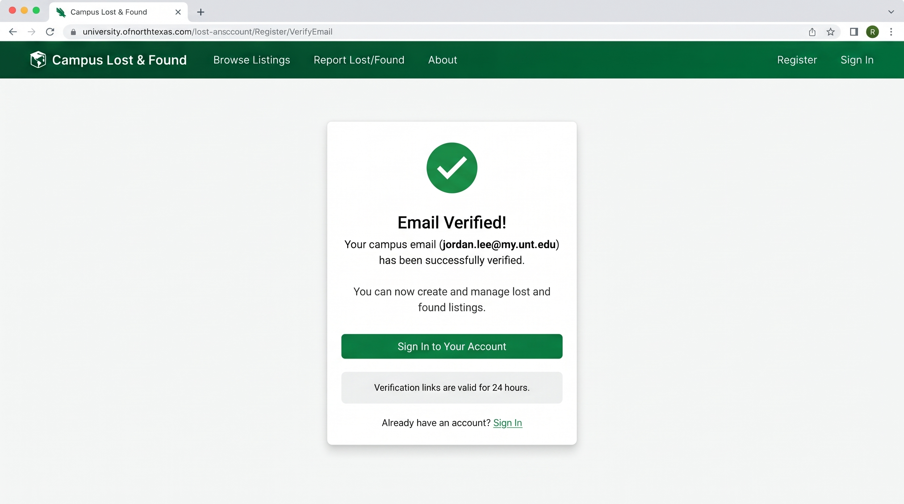
Figure 2. Email verification confirmation screen

5. Signing In and Out
Select Login, enter your email and password, and submit. A successful sign in takes you to the Listings page. If your credentials are not recognized, the application shows a single, generic "Invalid email or password" message; it does not reveal whether the email or the password was the problem, which is a deliberate privacy protection.
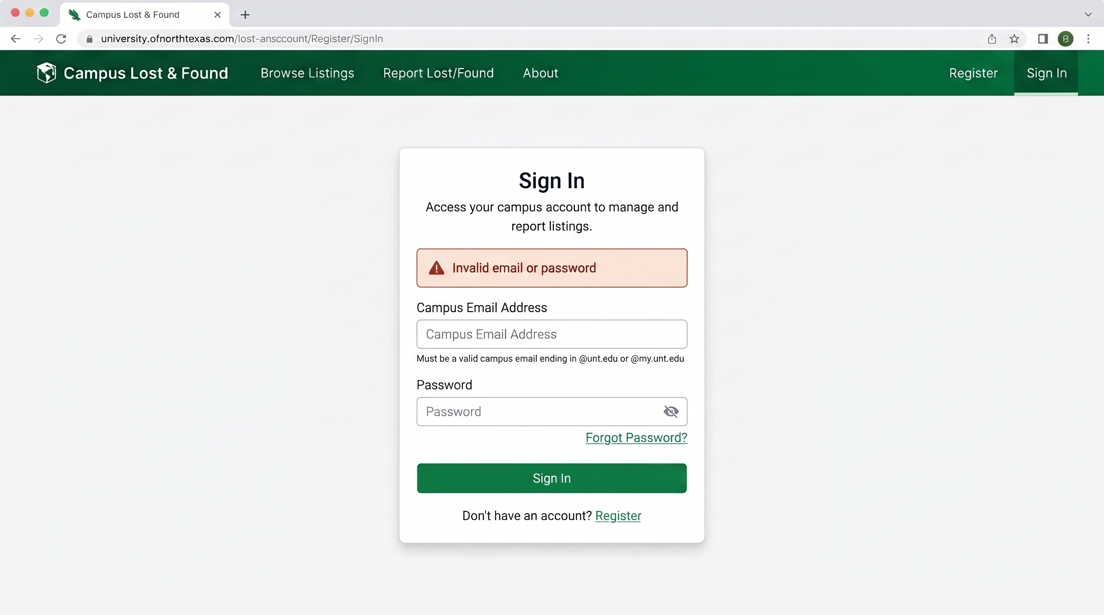
Figure 3. Login page

Once signed in, the navigation bar shows a Create Listing link, a Notifications link, and a Logout button in place of Login and Register. Selecting Logout immediately signs you out on this device; you will need to sign in again to create, edit, or delete a listing.

6. Resetting a Forgotten Password
If you cannot remember your password, select Forgot your password? on the Login page, enter your email, and submit. For your privacy, the application shows the same confirmation message whether or not that email actually has an account; this prevents anyone from using this form to discover who is registered.
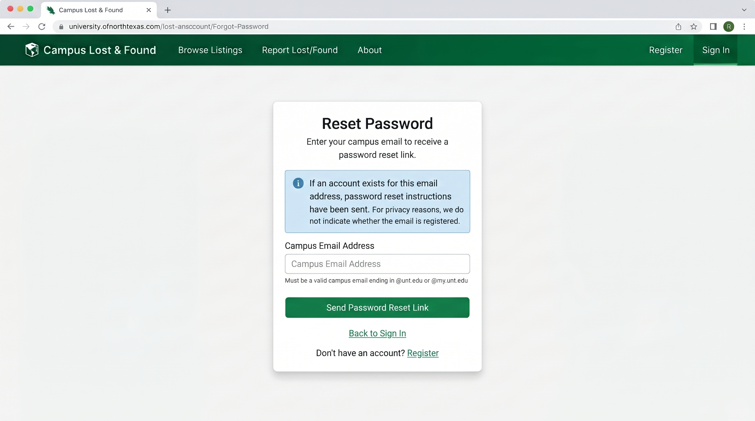
Figure 4. Forgot Password confirmation

If an account exists, a reset email is sent with a link valid for 1 hour. Opening it brings you to a page where you set a new password, at least 8 characters, entered twice to confirm it was typed correctly.

7. Browsing and Searching Listings
Select Listings from the navigation bar. You do not need to sign in to browse or search; this page is open to any visitor. Only Active listings (ones that have not been resolved or removed by their owner) are shown.
You can combine any of the following at once:
- Search: matches your keywords against each listing's title, description, and category.
- Type: Lost or Found.
- Category: for example Bags, Electronics, Keys.
- Building and Zone: the campus location where the item was lost or found.
- Date From / Date To: restricts results to a date range.
Results are shown 20 at a time, with Previous and Next controls at the bottom of the page. Selecting Clear resets every filter and returns to the first page.
If you are signed in and a listing is one you posted yourself, Edit and Delete buttons appear directly on that listing's card; they do not appear on listings posted by other people.
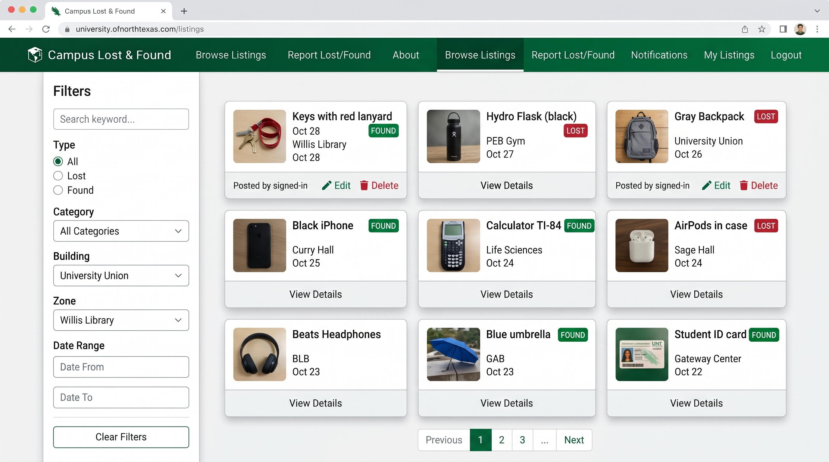
Figure 6. Listings page with search and filter controls

8. Creating a Lost or Found Listing
You must be signed in and have a verified email to create a listing. Select Create Listing and complete the form:
- Type: choose Lost or Found.
- Title, Category, Description, and Date: all required.
- Building: required. Zone is optional and narrows the location further.
- Photos: choose up to 3 image files (JPEG, PNG, or WebP, 5 MB or smaller each). A Found listing requires at least one photo; a photo is optional for a Lost listing, since you may not have one of an item you lost.
- Private Identifying Details: optional, for Found listings. Describe something only the true owner would know (an engraving, a sticker, contents of a bag). This is never shown on the public listing, in search results, or to anyone other than you; it exists so you can verify a claimant's identity later during the claim review step.
Submitting the form with a required field missing does not clear anything you already entered; the specific missing or invalid field is identified on screen so you can fix just that one field.
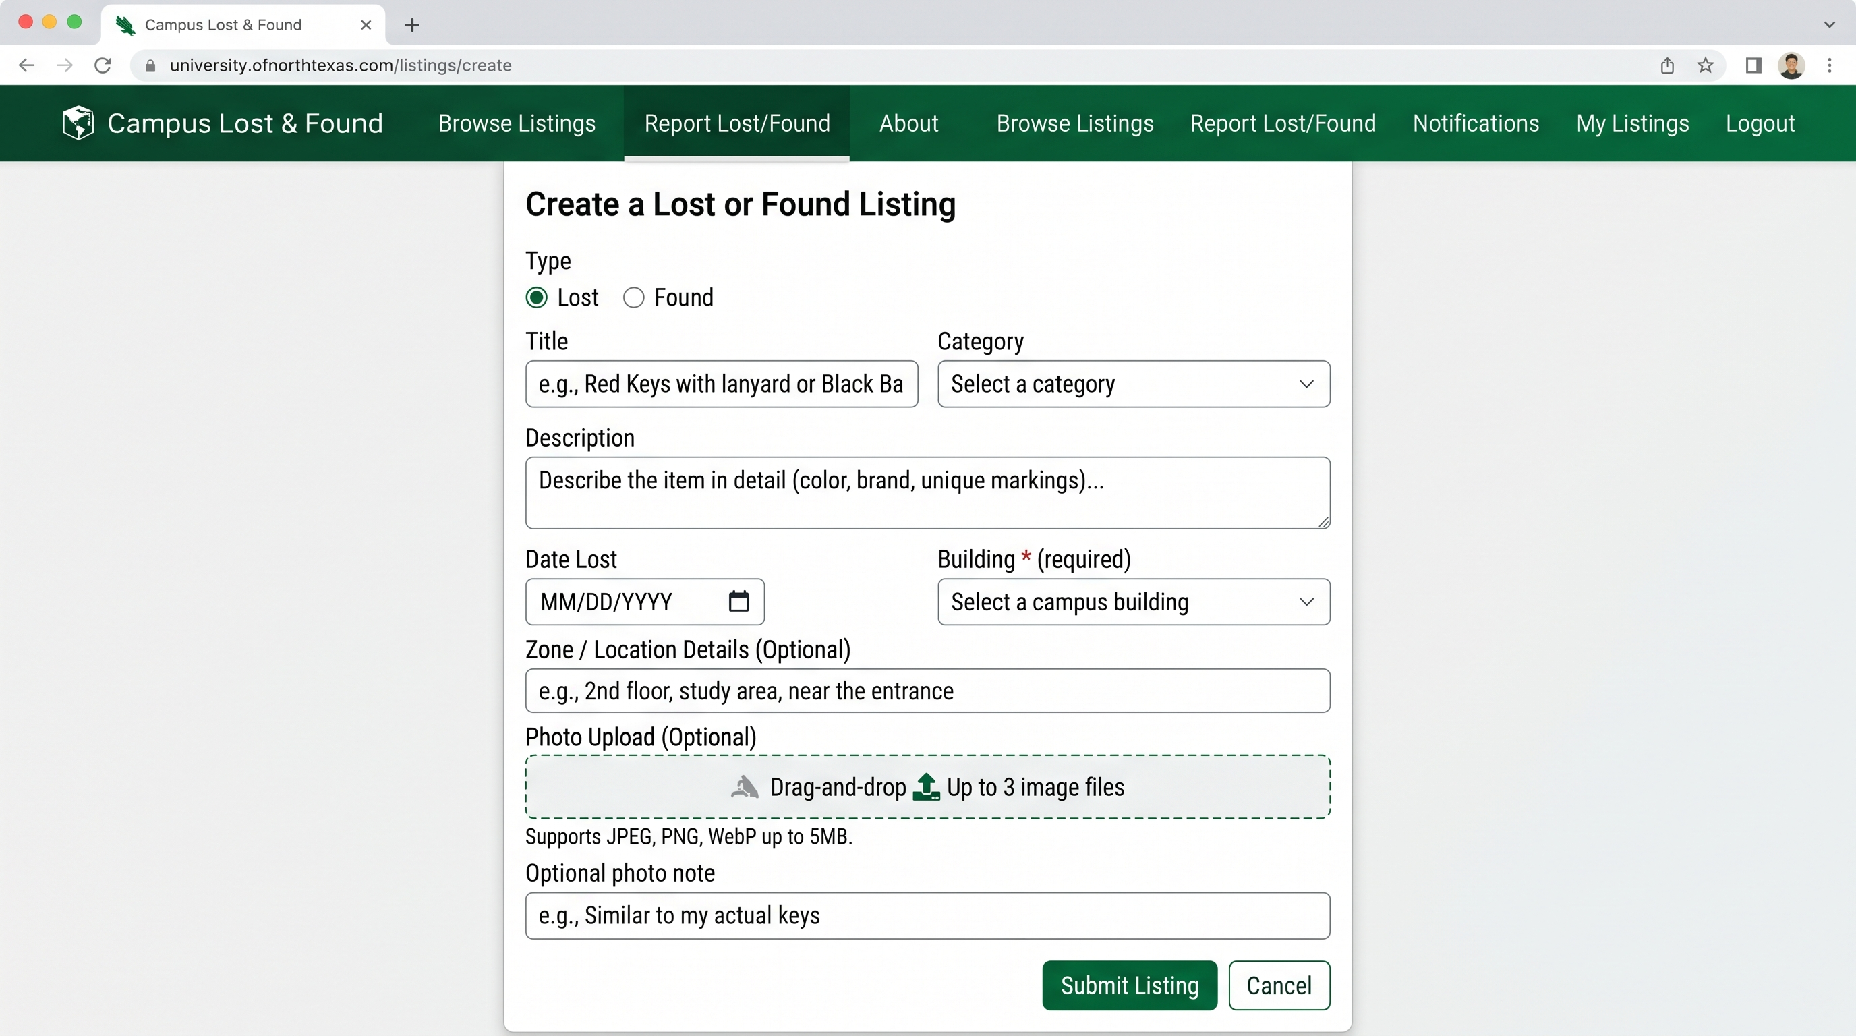
Figure 7. Create Listing page

9. Editing Your Own Listing
From the Listings page, select Edit on any listing you posted. The form opens pre-filled with that listing's current information. Change whatever you need and select Save Changes.
Photos are optional on this form: leave the photo field empty to keep the listing's existing photos exactly as they are, or choose new files to replace all of them at once.
Only the original poster can edit a listing. If you attempt to edit a listing you do not own (for example, by opening its edit link directly), the application rejects the request.
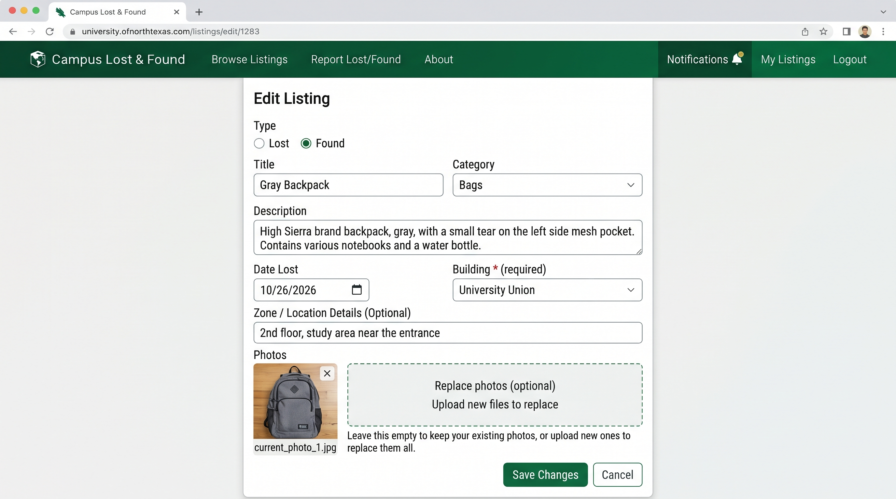
Figure 8. Edit Listing page

10. Removing Your Own Listing
Select Delete on a listing you posted. You will be asked to confirm before anything happens. Deleting a listing removes it from the public Listings page immediately; the record itself is kept rather than erased, consistent with how the course project is designed, but you will no longer see or be able to recover it from the application. As with editing, only the original poster can delete a listing.

11. Understanding Notifications
When you post a listing, the matching engine searches existing listings for similar items. If a likely match is found, you receive a match notification; the person who posted the matching listing also receives a notification, and they will see a claim submission form if they want to claim your item.
From the navigation bar, select Notifications to see all pending match notifications and claim activity. You will also receive in-app alerts (notifications shown at the top of the page) and email notifications when:
- A potential match is found for one of your listings.
- Someone submits a claim to one of your listings (you see this as a claim to review).
- A claim you submitted is approved or rejected.
- Someone sends you a message in an active message thread.

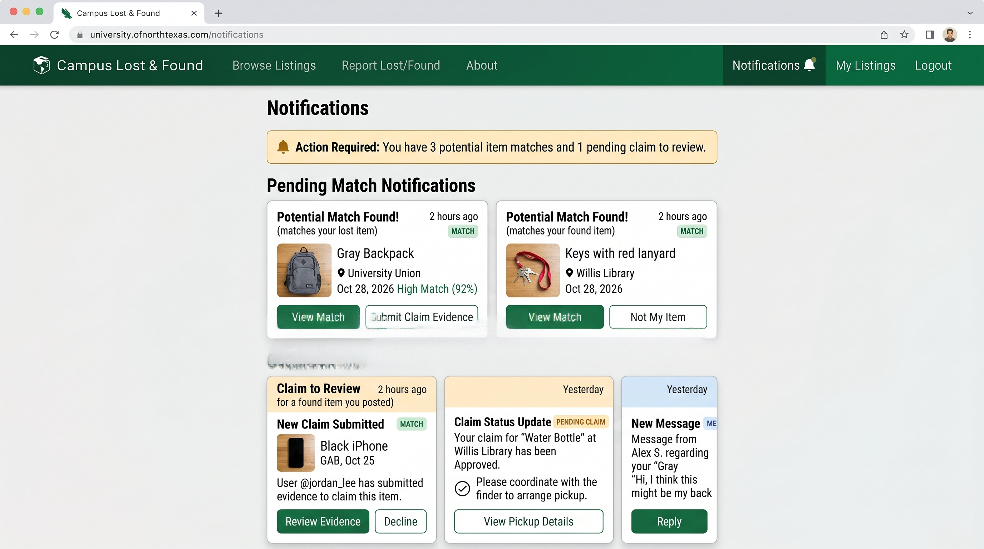Figure 9. Notifications page

12. Responding to a Match Notification
When the matching engine finds a potential match for your listing, you receive a notification with the matching listing's title, location, and primary photo. You can review the match details from either the Notifications page or from the badge on the listing itself.
Selecting Review Match shows both listings side by side so you can compare them. The matching listing's public details are shown, but not the private identifying details (those are only revealed if the matching person submits a claim). A score from 0 to 1.0 appears, indicating the engine's confidence that these are the same item; higher scores mean the engine found more similarities.
From this screen you can:
- Accept the match and wait for a claim. The system stays ready to receive claim evidence if the other person decides to submit one.
- Reject the match if you are certain it is not the same item. Rejected matches do not appear again; you can re-enable matching for this pair of listings if you change your mind.
- Go back without making a decision and review it later.
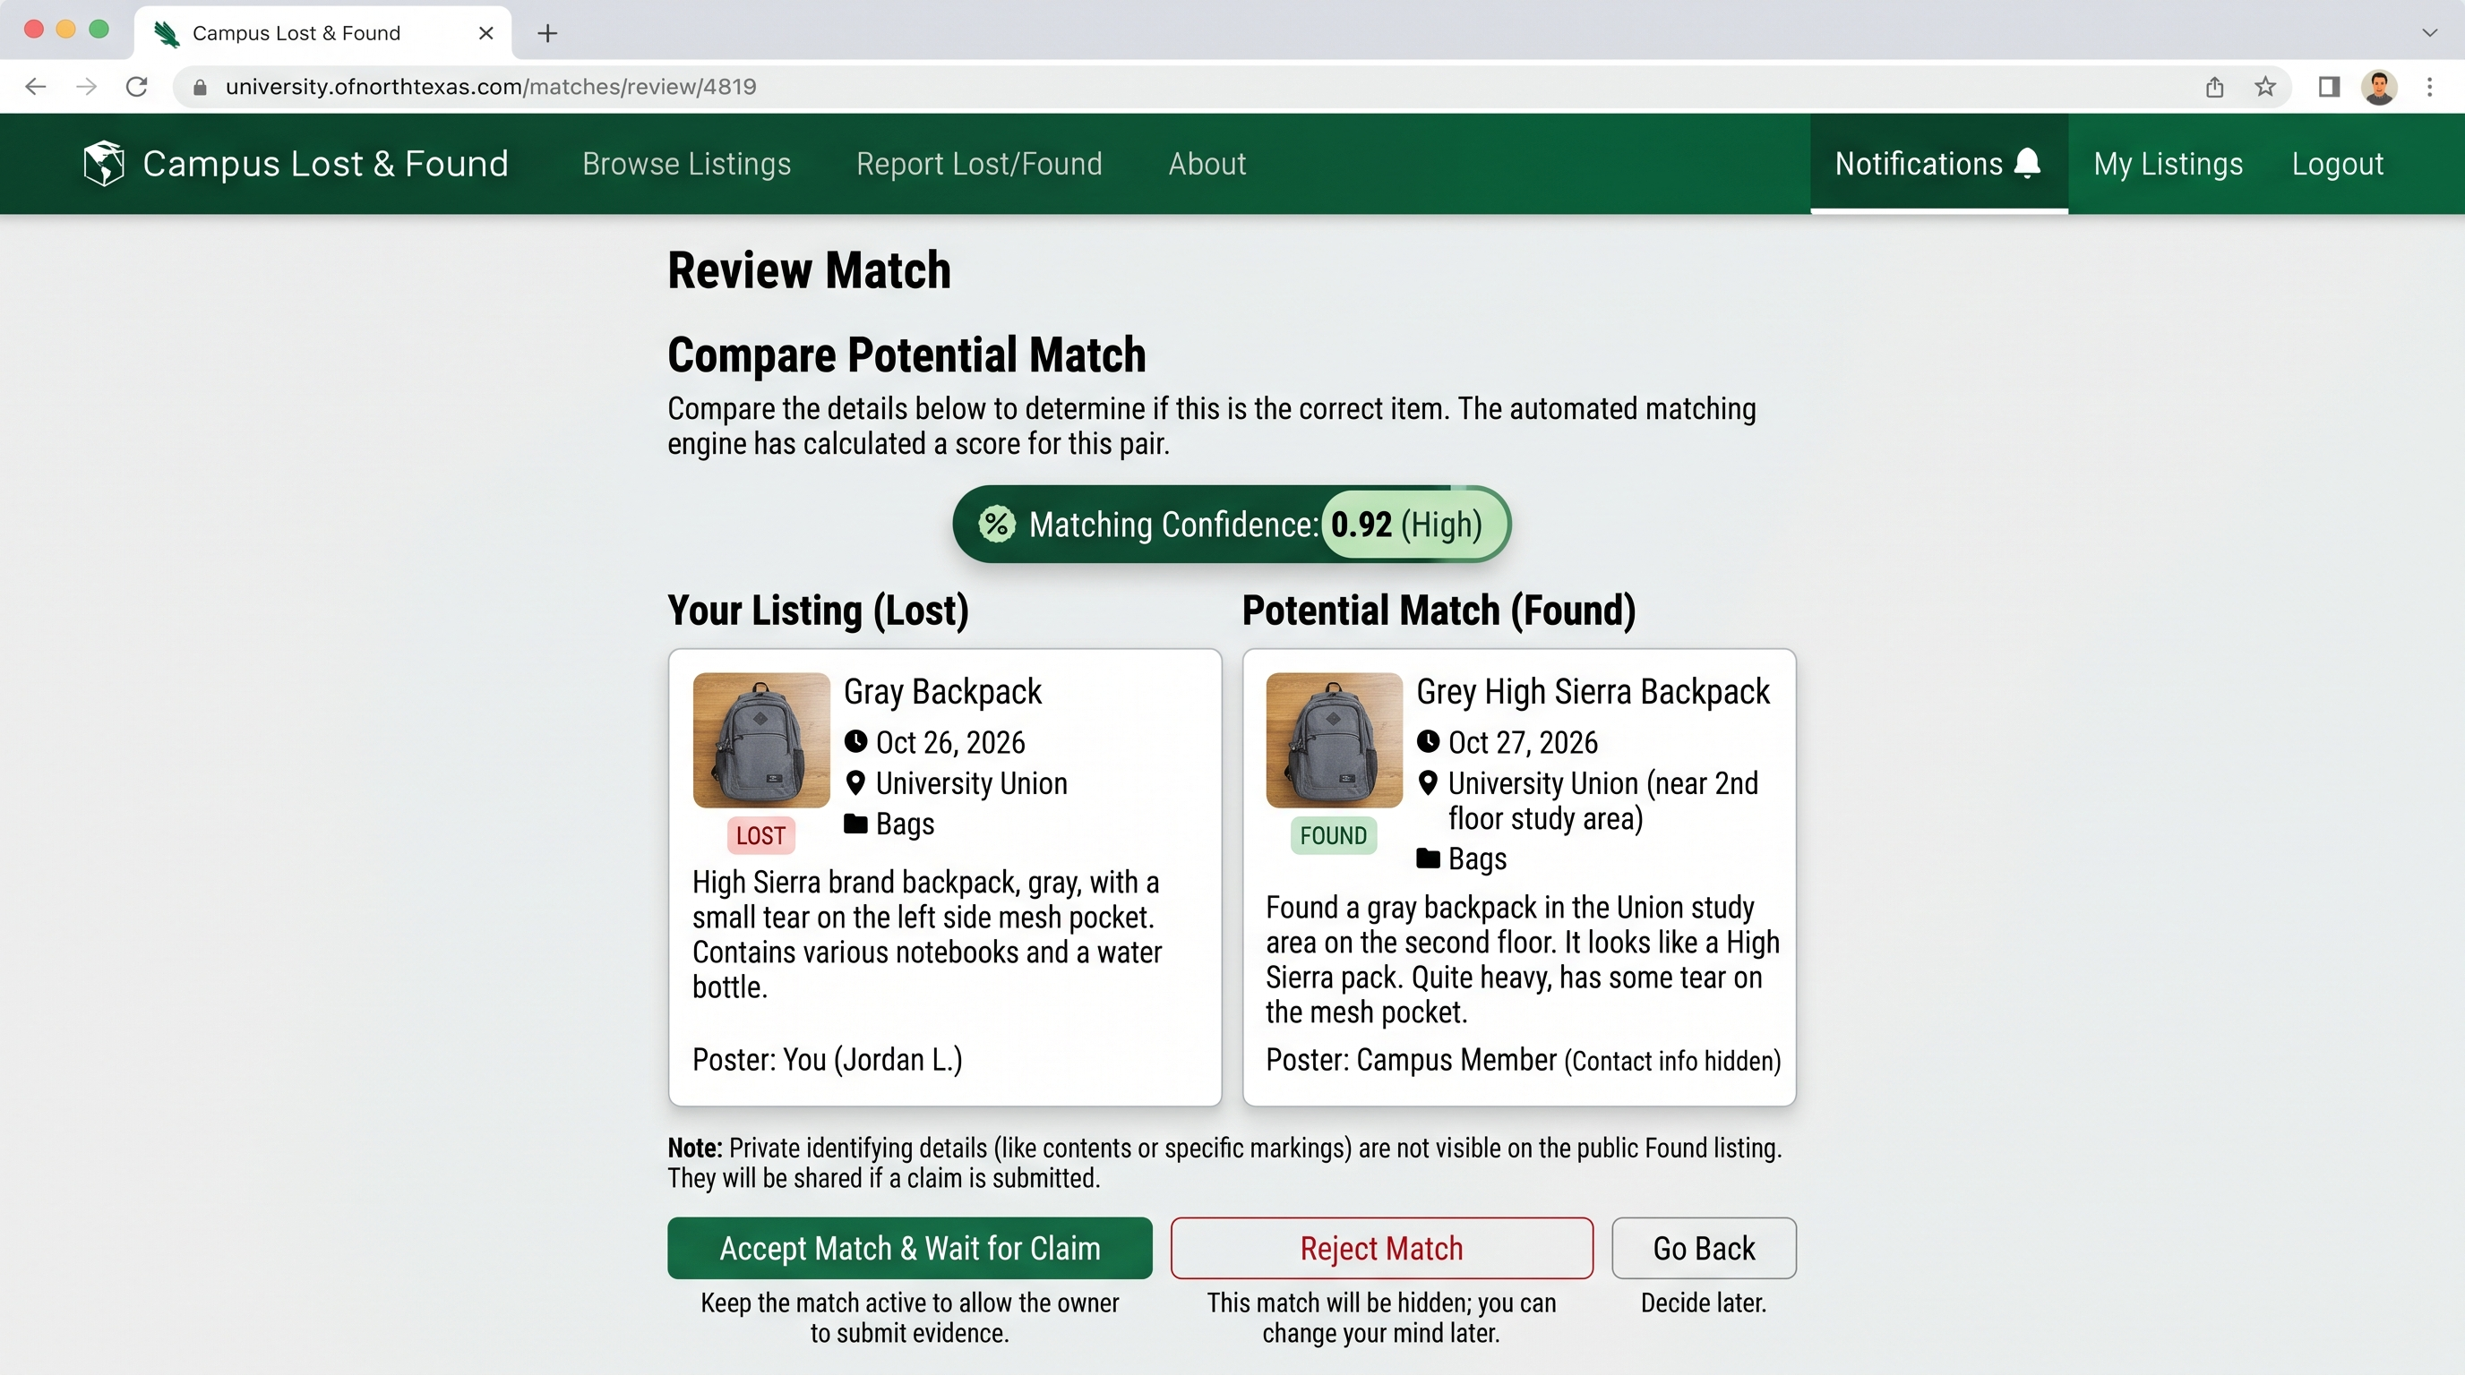
Figure 10. Match review screen

13. Submitting Claim Evidence
If you see a match notification and you believe you have found (or lost) the matching item, you can submit a claim. Select Submit Claim from the match notification or match review screen.
A claim form opens where you provide:
- Evidence Description: required. Describe identifying details that prove you own or found the item. For a Lost item you are claiming, describe details from your own experience. For a Found item you are claiming to own, describe details that match the private identifying details the finder stored.
- Evidence Photos: optional. You may submit up to 2 photos of the item you found, or yourself with the item, to strengthen your claim.
Submit the form and the claim is sent to the owner of the matching listing. They will see a notification that a claim has been submitted and can review your evidence. You will see a confirmation message and the claim moves to Pending status.
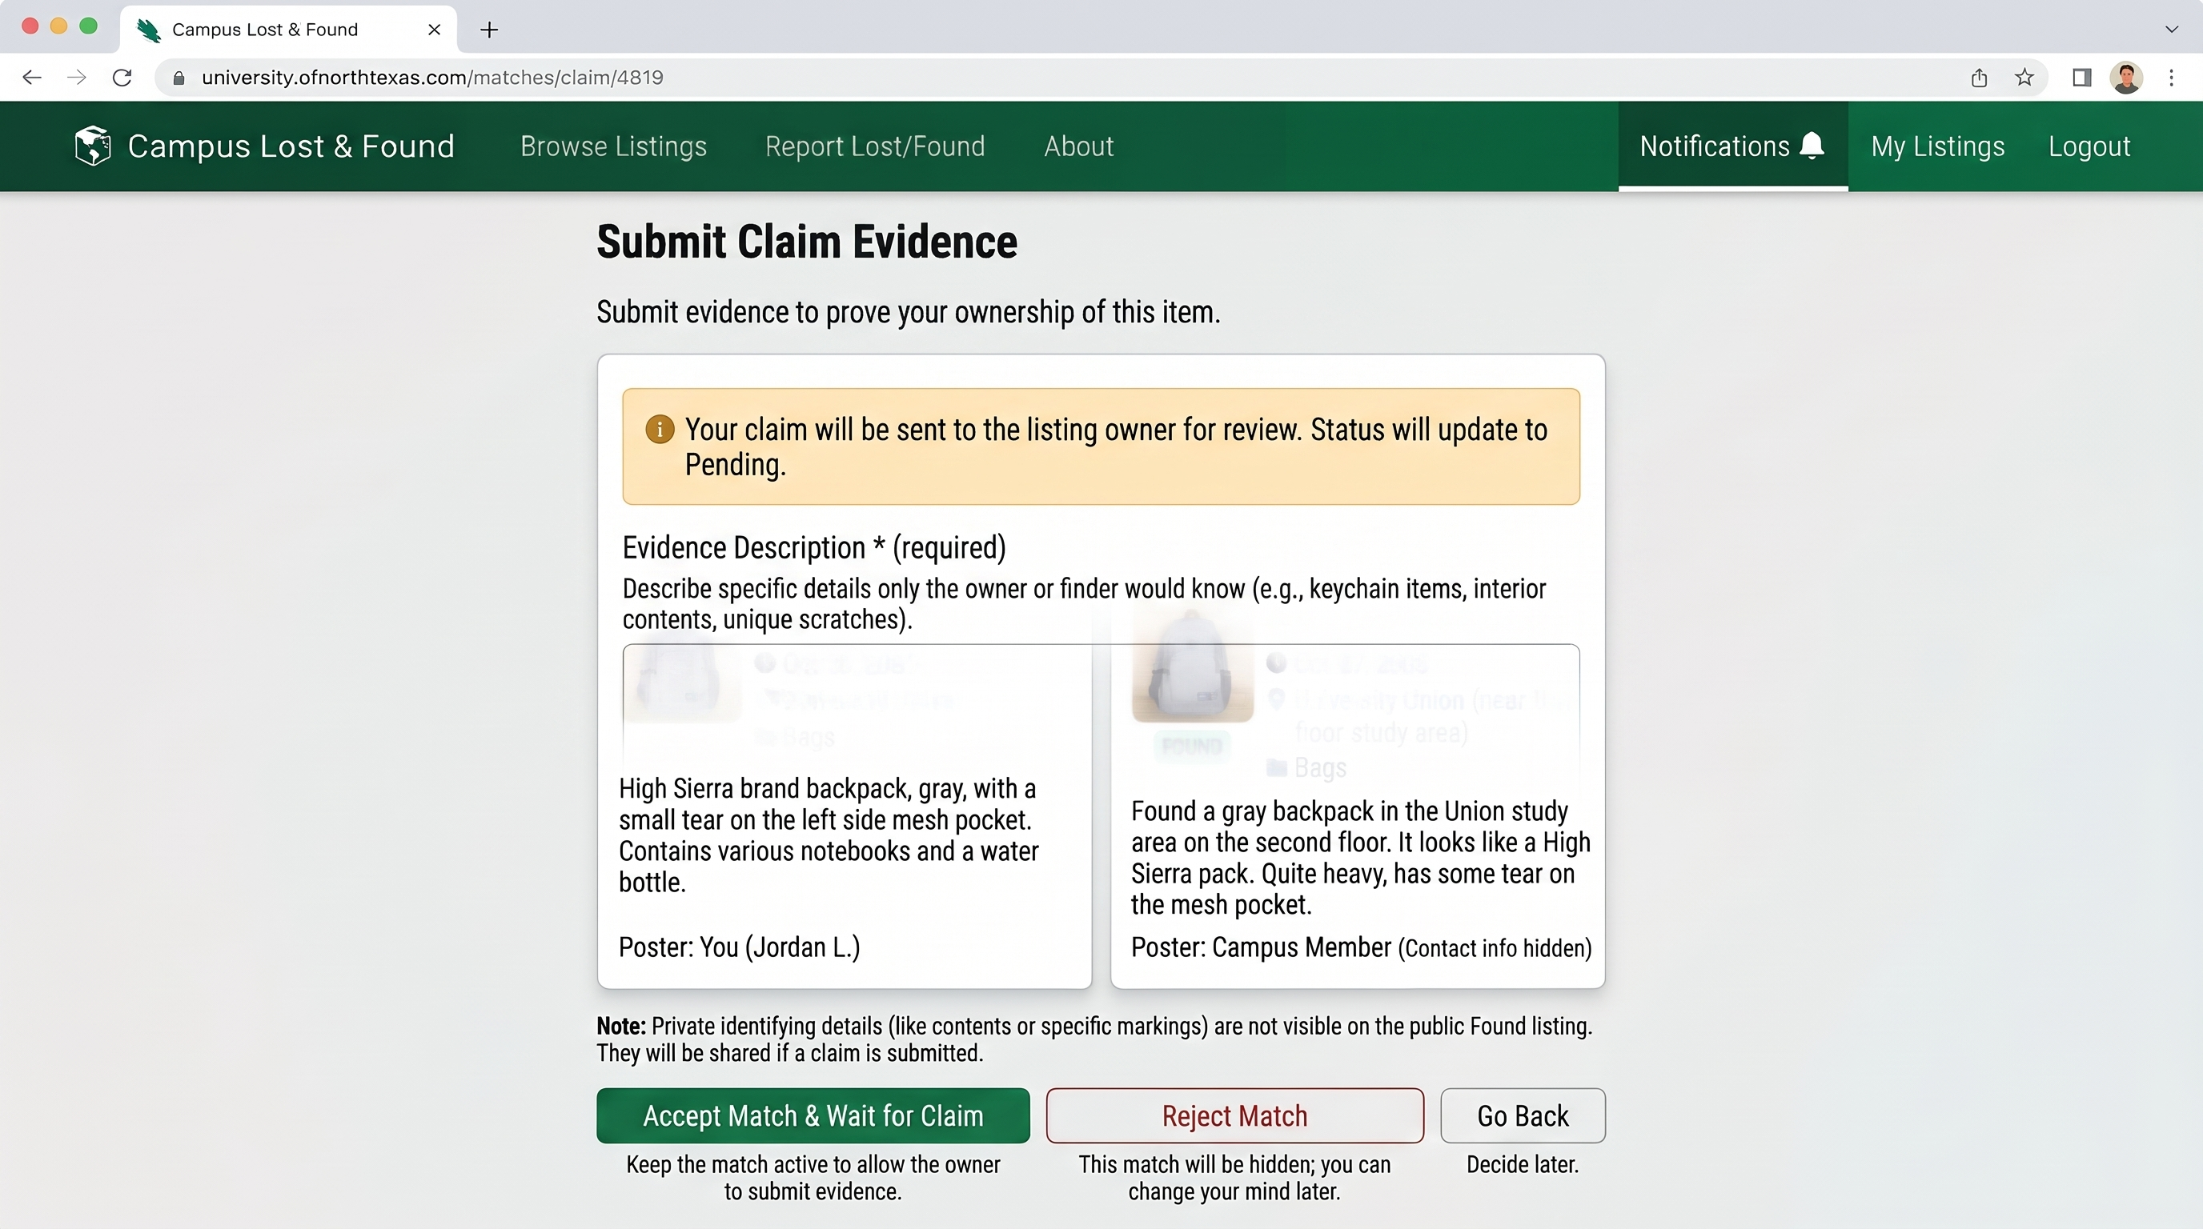
Figure 11. Submit Claim form

14. Reviewing and Approving Claims
When someone submits a claim to one of your listings, you receive a claim review notification. The notification includes the claimant's name and the item they are claiming.
Select Review Claim from the notification to see the full claim details. The claim shows:
- The claimant's evidence description.
- Any photos the claimant submitted as evidence.
- Your own private identifying details from when you created the listing, shown side by side with their claim so you can verify the details match.
The matching listing's details are shown for reference.
You can then:
- Approve the claim if the evidence matches your private details and you believe they are the true owner or finder. Approving opens an in-app message thread between you and the claimant so you can coordinate the handoff.
- Reject the claim if the evidence does not match your private details or you are not confident they are the right person. Rejecting keeps your listing Active so other claimants can submit evidence; you can change your mind and review the same claim again later.
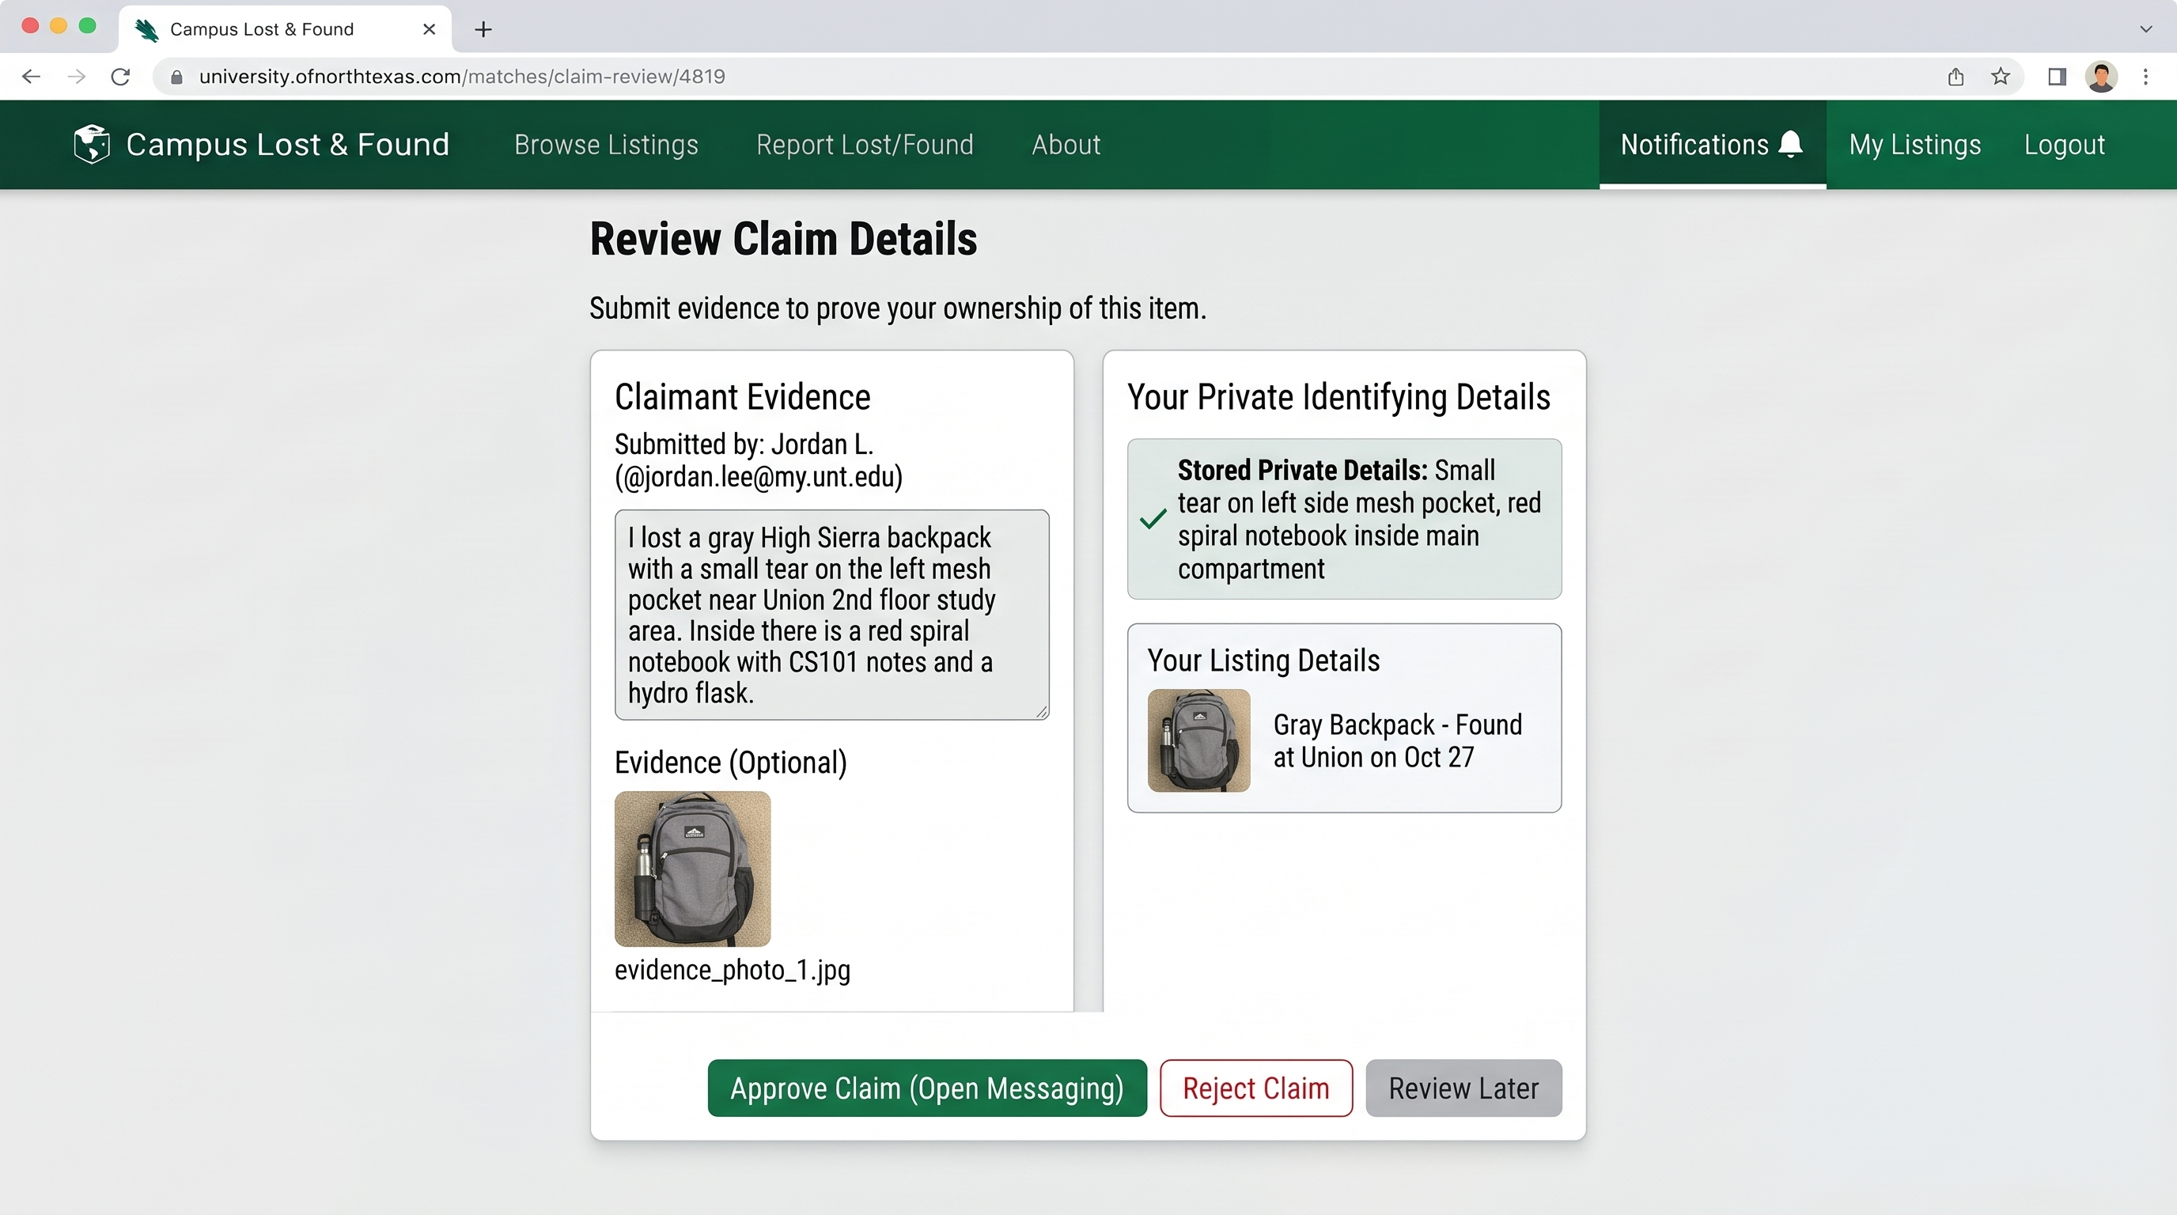
Figure 12. Claim review screen

15. Using In-App Messaging
Once you approve a claim, an in-app message thread opens automatically between you (the listing owner/finder) and the claimant. The thread is private to the two of you. Neither party's personal contact information such as phone numbers or personal email addresses is exposed in the messages; all communication happens through this secure channel.
From the Listings page or Notifications page, select Open Message or open the conversation from your notifications. The message interface shows the conversation history at the top and a text input field at the bottom.
Type your message, review it, and select Send. Messages are delivered immediately and both parties receive an in-app notification and an optional email notification that a new message has arrived. Read receipts are not shown; once you send a message, you can assume it was delivered.
When you and the other party have completed the handoff (either in person or through the messaging channel), the listing owner should delete or mark the listing as Resolved from the Listings page, which closes the match and the message thread.
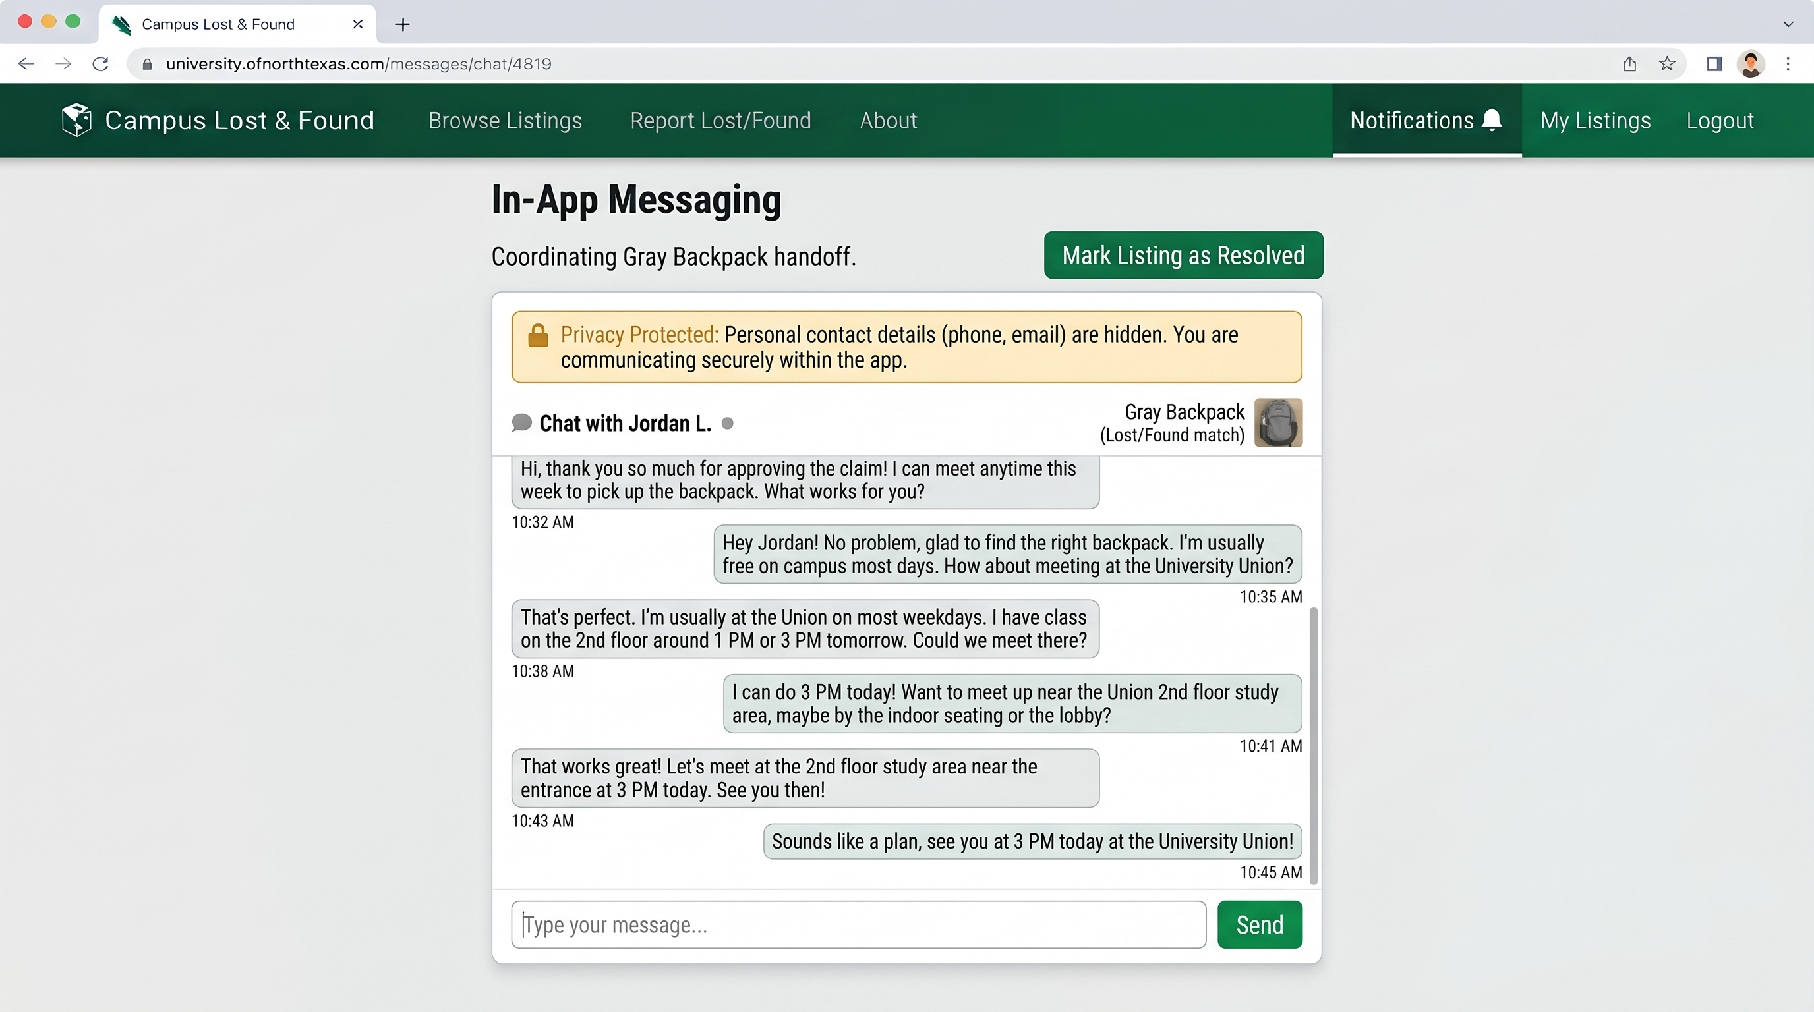
Figure 13. In-app messaging screen

16. Understanding On-Screen Messages
The application is designed to tell you specifically what went wrong rather than failing silently. The table below lists messages you are likely to encounter in Phase 2 and what to do about it.
Situation | What You See | What To Do
A required field is left blank or invalid | The field is outlined and a specific message appears directly beneath it (for example, a UNT email address is required). | Correct the field indicated and submit again. Every other field you already filled in stays as you left it.
Registering with a non UNT email | "Please use a valid UNT email address." | Use an address ending in @unt.edu or @my.unt.edu.
Signing in with the wrong email or password | "Invalid email or password." | re-enter your credentials, or use Forgot your password? if you are not sure.
Creating a listing before verifying your email | "Please verify your email before creating a listing." | Check your inbox (or the development console, during testing) for the verification email and follow its link, then try again.
Submitting a claim with missing evidence description | "Evidence description is required." | Provide a description of the identifying details that prove you own or found the item.
Submitting evidence photos over 5 MB each | "Each evidence photo must be no more than 5 MB." | Reduce the file size or choose a different photo.
Attempting to submit a claim after the match has been rejected | "This match is no longer available for claiming." | If you believe there is still a match, review the listings manually and contact the posting user if appropriate through other channels (this is outside the Lost and Found application).

17. Frequently Asked Questions
Why can't I create a listing right after registering?
Your email must be verified first. Check your inbox for the verification email and follow its link.
Can I see other people's private details on a Found item?
No. Private identifying details are visible only to the person who posted the listing. They are never included in public listings, search results, notifications, or anyone else's view unless they submit a claim for review.
Can someone else edit or delete my listing?
No. Only the account that created a listing can edit or delete it, regardless of what any screen shows.
What happens if I lose my password and never requested a reset?
Use Forgot your password? on the Login page at any time; it works even if you never used it before.
How many photos can I attach, and in what format?
Up to 3 photos per listing, each a JPEG, PNG, or WebP file no larger than 5 MB. For claim evidence, you can submit up to 2 evidence photos using the same formats and size limit.
Why did I receive a match notification for two items that don't look the same?
The matching engine compares category, location, date, and keyword similarity. Items in the same category at the same location posted near the same date are flagged as potential matches so you can review them. The score (0 to 1.0) reflects how confident the engine is. Always review the full details yourself before approving or rejecting a match.
What if I approve a claim but then realize it's the wrong person?
Once a claim is approved, the message thread opens and the listing is marked as claimed. If you realize there is a mistake, communicate with the claimant through the message thread. You can then decide whether to work out the situation, or if you need to escalate, contact campus security or the lost and found office directly.
Can I send messages before a claim is approved?
No. Message threads only open after a claim is approved. Before approval, you can review the claim evidence and accept or reject it, but you cannot send messages. Once approved, the thread opens and you can communicate.
Are messages saved if I delete my account or the listing?
During the course project, deletion removes the listing from public view, but records are kept internally. Messages in an approved claim thread are part of that record. If you have completed the handoff, you can delete the listing (which marks it as resolved) and the message thread will close.
Can I resubmit a claim if it is rejected?
No. Once you submit a claim and it is rejected, you cannot resubmit evidence for the same listing. You can, however, browse and search for other similar listings and submit claims to those instead.

18. Quick Reference: Typical Phase 2 Workflow
- Register with a campus email address.
- Verify your email from the link sent to you.
- Sign in.
- Browse or search for an item.
- If it is not already listed, create a Lost or Found listing and save it.
- Watch for match notifications. When a potential match is found, you receive a notification in the browser and via email.
- Review matches at your own pace from the Notifications page or from badges on your listings.
- If you believe a match is your item, submit claim evidence describing identifying details.
- If a claim is submitted to one of your listings, review the claimant's evidence and compare it to your private identifying details.
- Approve the claim if the evidence matches. An in-app message thread opens.
- Use the message thread to coordinate the handoff (time, location, etc.).
- Once you have completed the handoff in person, delete or mark the listing as Resolved.
- Sign out when finished.

